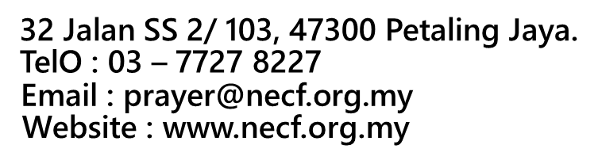
40-DAY PRAYER BOOKLET
AUG.07 – SEP. 15, 2026
THEME: “WALK IN HUMILITY”
( Please TICK [ √ ] the appropriate box )

RM3/Bk  Collection  Own |  |  | | Sabah & Sarawak – RM4/Bk [ ]  Semenanjung – RM4/Bk [ ]  Post :
** Price per book is inclusive of postage charges. Minimum Order : 5 copies
Person in Charge
HPNo.: |  |  |  | Email:
Church :
Delivery Address :
No | Description |  |  |  |  | Qty | Unit $ per Book | Total Cost (RM)
1 | Adult Version – English Prayer Booklet
2 | Adult Version – Chinese Prayer Booklet
3 | Adult Version – Bahasa Malaysia Prayer Booklet
4 | Adult Version – Tamil Prayer Booklet
5 | Children Version – English Prayer Booklet
6 | Children Version – Chinese Prayer Booklet
7 | Children Version – Bahasa Malaysia Prayer Booklet
TOTAL

Signature: Date:

Payable to “National Evangelical Christian Fellowship A/C 2”
Public Bank Bhd No: 3 1408 9263 5
(Important: You must email over bank-in slip/bank transaction to NECF as proof
of payment or email at prayer@necf.org.my

For Office Use:
Collected by: | Payment Mode: | Receipt No: | Amount:

