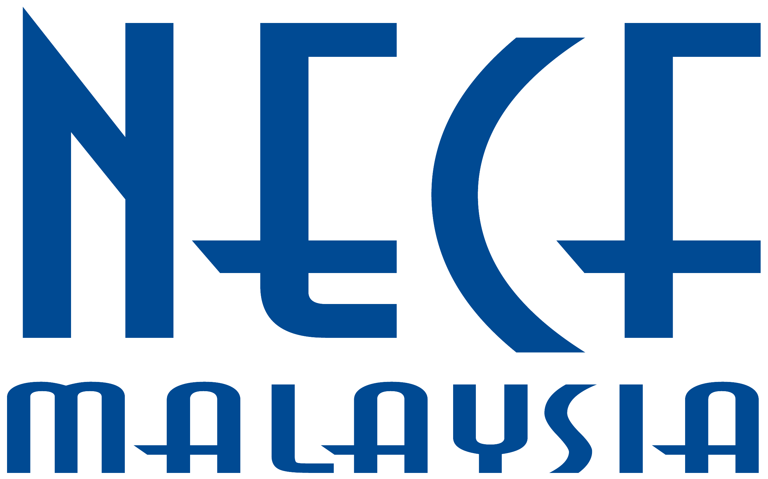
32 Jalan SS 2/103,
ORDER FORM
47300 Petaling Jaya, Selangor
Tel : 03-7727 8227; Fax : 03-7729 1139
Email: prayer@necf.org.my; Website: www.necf.org.my

“LET YOUR KINGDOM COME ” 2013 40-Day Fast & Prayer

Own Collection RM2.00 per set
West Malaysia - Inclusive of postage RM2.50 per set
East Malaysia - Inclusive of postage RM3.00 per set

Name of Church/Organisation:__________________________________________________
Name of Pastor/Elder/Leader/Person Incharge: ____________________________________
Delivery Address: (Not P.O.Box Address)
Street: ______________________________________________________________________
____________________________________________________________________________
Postcode: ______________ Town: __________________ State: _____________________
TelO: __________________ Fax: ____________________ H/P: ________________________
Email: _______________________________________________________________________

Description |  |  | Quantity | Unit Price | Amount (RM)
Adult Edition |  | English
 |  | Chinese
 |  | Bahasa Malaysia
 |  | Tamil
Children Edition |  | English
 |  | Chinese
 | Total: |  |  | Total Amt:

Signature: __________________________ Date : ____________________

Make Cheque payable to NECF A/C 2. Send Cheque to us or Bank into Public Bank Bhd. A/C No: 314-089-2635
(Important : You must fax over bank-in slip/bank transaction to NECF as proof of payment.)

For Office Use Only

 | Amount | : | ______________ |  | Cash/Cheque/MO | : | ______________
 | Receipt No. | : | ______________ |  | Date payment received | : | ______________

