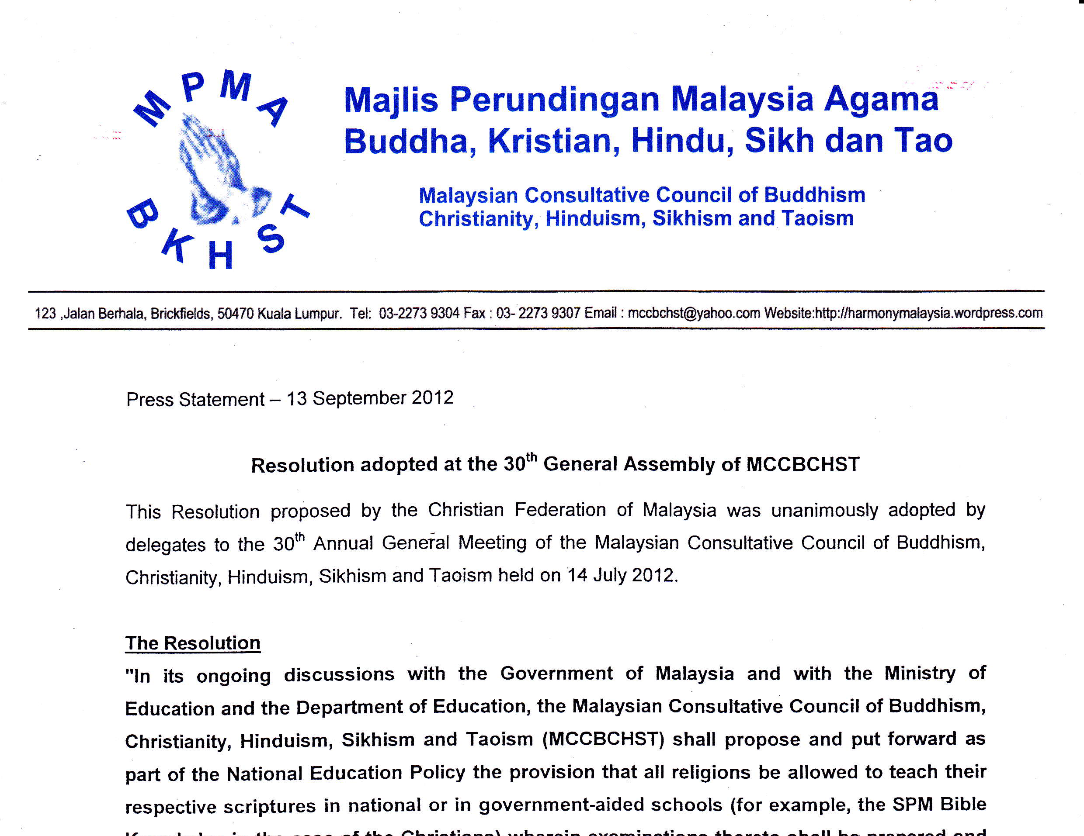

18 November 2012

MCCBCHST Press Statement

NRD MUST RECOGNISE THAT HISTORICALLY “BIN AND “BINTI” USED BY BOTH CHRISTIANS AND MUSLIMS IN SABAH AND SARAWAK

The Malaysian Consultative Council of Buddhism, Christianity, Hinduism, Sikhism and Taoism (MCCBCHST) notes with alarm the National Registration Department‘s (NRD) actions in Sabah where they have unilaterally and arbitrarily listed practising Christians as Muslims in their identity cards simply because they have ‘bin’ or ’binti’ in their names.

The NRD’s further decision that it would continue to list such Bumiputra Christians as Muslims until they have obtained an order from a Syariah court to say that they are not Muslims is a violation of the affected persons constitutional rights and Fundamental liberties as enshrined in Article 11[1] and 12[4]of the Federal Constitution.

The NRD should note the Historical position that in Sabah ‘bin’ and ‘binti’ does not necessarily mean they are Muslims. More so as the test case filed by Intim bt Lambaran and her 2 daughters show that they had been baptized as Christians and were never at any time Muslims. These facts have been sufficient for those like Intim binti Lambatan to be listed as Christians in their MYKAD by the NRD.

In the present case Intim binti Lambatan should have filed a Writ action in the Civil High Court to compel NRD to list them as Christians in their MYKAD and not the Shayriah Court, as the SYARIAH COURT HAS NO JURISDICTION OVER NON-MUSLIMS.

In the latest case of SITI HASNAH VANGARAMA ABDULLAH v TUN DR MAHATHIR MOHAMMAD (as the President of Perkim) & ORS (Current Law Journal dated 30/7/2012 – Express Reporting Services) facts showed that Vangarama’s Hindu parents had converted to Islam in 1983 and purportedly converted her to the Islamic faith. The Islamic Religious Department, Pahan through an Affidavit stated that Vangarama’s parents had converted to Islam in 1983 and also converted their 5 children to Islam including Vangarama who was only an infant aged 1 year 3 months at the time. Vangarama contested her conversion and despite PERKIM and Majlis Agama Islam Negeri Pulau Pinang saying that Vangarama was properly converted and that her case must be tried by the Syariah Court. The Court of Appeal refused to accept this argument and ruled that there being contest of facts, the matter must be decided by the Civil High Court. The Court of Appeal further added that there were also important constitutional issues to be decided, which came under the Civil High Court jurisdiction only and not the Syariah Court.

The NRD is thus acting unconstitutionally and in an arbitrary manner. Intim binti Lambatan and her daughters are advised to file a writ Action immediately against the NRD Department as advised in the Vangarama’s case quoted above.

The People of Sabah should demand accountability from their government and elected leaders for this sad state of affairs. They are the ones who have allowed this to happen and remained passive.

MCCBCHST therefore urges that the Home Minister direct the National Registration Department to rectify and reflect the true religion of the aggrieved party upon notification without reference to any third party.
